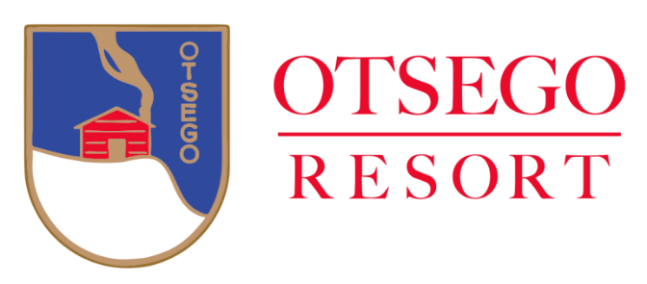

The Otsego Resort is hosting a benefit golf outing for the T.A.C.K.L.E. fund with a 4 person scramble on the Tribute Course Rain or Shine at 11:00 am on Wednesday, June 26, 2024. T.A.C.K.L.E. stands for Together Against Cancer Kept Local Every day. The money is used for comfort, care, and transportation of Otsego County residents for cancer treatment. Otsego Resort is located at 696 M-32 East, Gaylord, Michigan.
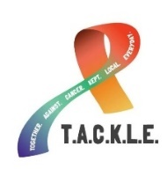
This event includes box lunches on the golf carts and a cookout served immediately after golf is completed. Golfers have the option to participate in skins and other golf contests while they are on the course. There will be a silent auction & a 50/50 Raffle during dinner.

- Premier sponsor - $1000 ~ 1 four (4) team entry with recognition on social media, hole sponsor sign, and your banner at dinner.
- Gold sponsor - $500 ~ recognition on social media, hole sponsor sign, and your banner at dinner.
- Bronze sponsor - $200 ~ hole sponsor sign
- The cost is $440.00 per 4 player team.
- Dinner only (no golf) will cost $30.00 and can participate in the silent auction & 50/50 raffle.

Pre-registration is requested by Monday June 17, 2024.

Name: _______________________ 1st Golfer _________________________

Company: ____________________ 2nd Golfer _________________________

Address: _____________________ 3rd Golfer _________________________

_____________________ 4th Golfer _________________________

Phone: _______________________ Contact email: ____________________________

Enclosed is $_________ for ____ a team at $440 per team.
Enclosed is $_________ for ____ dinner tickets @ $30.00 each (for only dinner).
Enclosed is $ _______ for a _______________ sponsor or call for sponsor information at the number below.

Mail checks and registration payable to Otsego Resort C/O NuEnergy, LLC at PO Box 1122, Gaylord, Michigan 49734. Please contact NuEnergy, LLC at (989) 731-0590 with any questions.
Checks MUST be made out to Otsego Resort.

